HW: Environment Setup (SETUP.md Part A + Wallet)
Read and complete Part A of the course setup guide:
https://vanlam2027.pythonanywhere.com/ai_finance.html
Then do the first two steps of Part B (no funds needed):
run gen_wallet.py to create your wallet, and run read_chain.py to read Ethereum mainnet.
Submit 3 screenshots:
1. Your terminal showing (ai_finance) in the prompt and the output of: python -c "import web3, eth_account; print('web3', web3.__version__)"
2. The output of gen_wallet.py — ⚠️ crop or cover your PRIVATE KEY, show only the ADDRESS
3. The output of read_chain.py (latest block + vitalik.eth balances)
Stuck on an error? Paste the full command + error into Claude Code and ask how to fix it on your OS — that's the intended workflow in this course, not cheating. If you're still stuck after that, post in the class forum.
1/ setup environment:

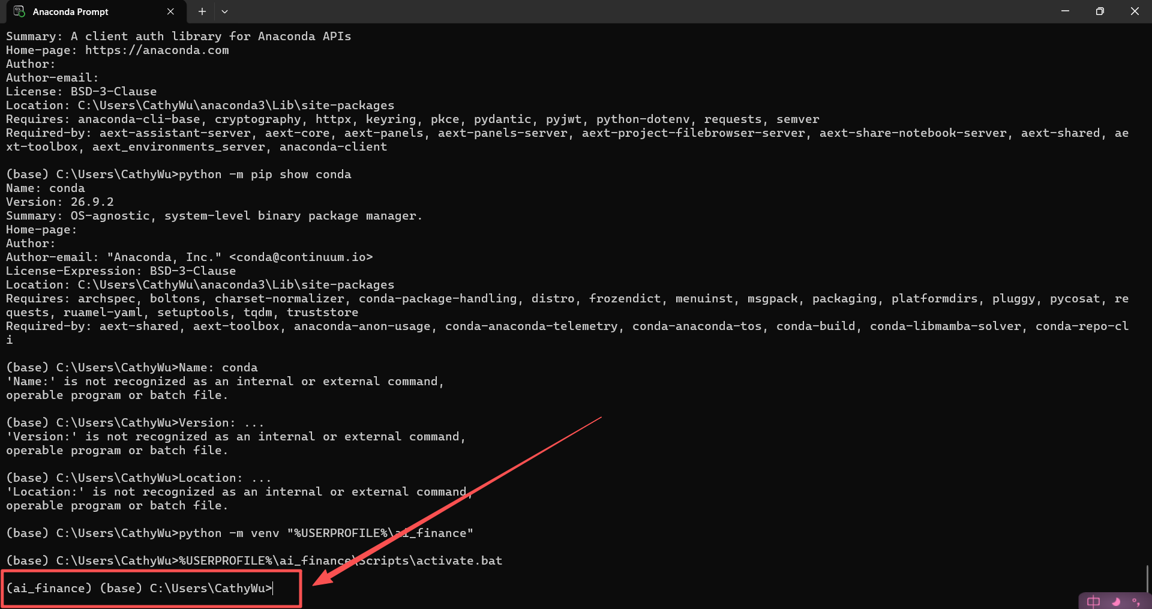

2/ Python setup:
python -m pip install web3 eth-account
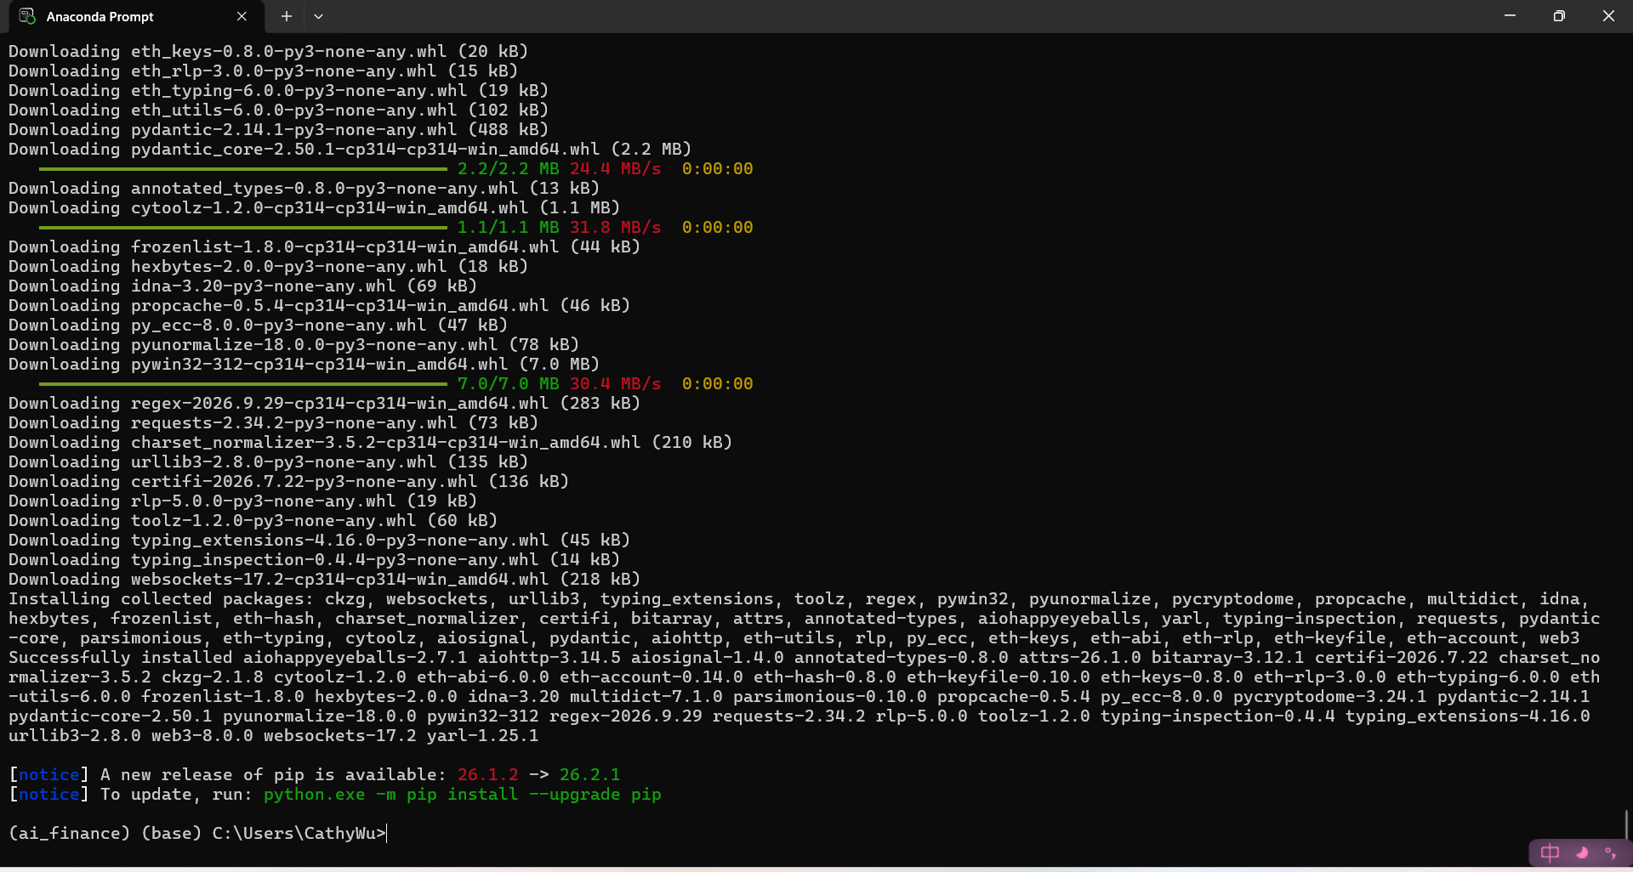

HOMEWORK SCREENSHOT:

